 | SIMATS ENGINEERING  Department of Computer Science and Engineering  CSA15 Cloud Computing and Big Data Analytics  CO2 AT3 - Capstone Cloud Infrastructure Case Analysis and Defense  Editable student template for application-based cloud virtualization and SDDC/cloud operations defense
Assessment Metadata
Course Code | CSA15
Course Title | Cloud Computing and Big Data Analytics
Assessment | CO2 AT3 - Capstone Cloud Infrastructure Case Analysis and Defense
Submission Type | Individual digital case analysis and infrastructure defense based on the same capstone title used in CO1, CO2 AT1 and CO2 AT2
Faculty | Dr C. Rajesh Babu
Employee ID | SSETSCS415
Submission Mode | Completed DOCX template and GitHub repository link through Google Classroom
How This Template Works
- Use the same capstone title used in CO1, CO2 AT1 and CO2 AT2.
- Do not recalculate all VM sizing or repeat all configuration screenshots. Summarize the final AT1/AT2 evidence and use it for design defense.
- Answer all five questions with application-oriented reasoning connected to the capstone product.
- Include sustainable cloud operation decisions wherever relevant: right-sized resources, log retention, storage lifecycle, scheduled shutdown, API-call reduction and VM/container/serverless comparison.
- Paste the final topology diagram in the given response area. The sample diagram is only a structure; redraw it for the student's own product.
- Upload this completed document and supporting evidence to GitHub, then submit the repository link through Google Classroom.
Assessment Focus
AT1 answered what VM is required. AT2 showed configuration or simulation evidence. AT3 asks whether the student can defend the complete infrastructure design under application, security, operations and failure conditions.
Student and Capstone Details
Student Name | G.Lakshmi Mounika
Register Number | 192372110
Class / Slot | Slot B
Capstone Title | Cloud-Based CropWater AI: Irrigation Scheduling and Water Stress
CO1 Evidence Link | https://github.com/gundalakshmimounika/CSA1512-CLOUD-COMPUTING
CO2 AT1 VM Recommendation | vCPU: ____ RAM: ____ GB Storage: ____ GB VM Class: ____
CO2 AT2 Evidence Link | https://github.com/gundalakshmimounika/CSA1512-CLOUD-COMPUTING
GitHub Repository Link | https://github.com/gundalakshmimounika/CSA1512-CLOUD-COMPUTING
Submission Date | 31-07-26
Evidence Carry-Forward Summary
Evidence Source | Student Entry | How It Supports AT3 Defense
CO1 concept map / presentation | Concept map on Cloud Infrastructure, Virtualization, SOA, Security, Green Computing, and SDDC | Provides the theoretical foundation for selecting and defending the proposed cloud infrastructure architecture.
CO2 AT1 sizing workbook | VM sizing based on application workload, CPU, RAM, storage, network, and scalability requirements. | Justifies the infrastructure capacity selected for the application and demonstrates that resources are appropriately sized.
VM calibration sheet | Recommended VM: 2 vCPU, 4 GB RAM, 50 GB SSD storage, Linux OS, scalable configuration. | Provides measurable evidence for the selected VM configuration and supports performance, cost efficiency, and future scalability.
CO2 AT2 practical evidence | VM creation, OS configuration, network setup, application deployment, testing, and monitoring evidence. | Demonstrates that the proposed infrastructure can be practically implemented, configured, tested, and operated successfully
Capstone architecture decision | Cloud-based scalable architecture using Virtual Machines, SOA/API services, cloud storage, security controls, monitoring, and backup. | Combines CO1, AT1, and AT2 evidence to defend the final architecture based on scalability, availability, security, performance, manageability, and cost efficiency
Q1: Virtualization Value and Capstone Cloud Deployment Summary
Explain your capstone product, expected workload, cloud need and deployment context. Analyze how virtualization improves cost efficiency, resource utilization, workload isolation, infrastructure flexibility and cloud deployment readiness for your product.
Design Point | Student Response
Capstone product and users | Cloud-Based CropWater AI is a smart irrigation system that uses cloud computing and AI to monitor soil moisture, weather conditions, and crop water requirements. It is mainly used by farmers, agricultural officers, and farm managers.
Expected workload | The system collects sensor data continuously, processes AI predictions, stores data in the cloud, and serves multiple users through a web dashboard. The workload increases during peak farming seasons, requiring scalable cloud resources.
Cloud need | Cloud computing provides scalable storage, real-time data processing, remote monitoring, backup, and high availability for irrigation management.
Virtualization value | Virtualization allows multiple virtual machines to run on one physical server, improving resource utilization, scalability, and efficient deployment of application services.
Cost and utilization benefit | Pay-as-you-use cloud services reduce hardware costs, minimize maintenance expenses, and optimize CPU, memory, and storage utilization.
Isolation and flexibility benefit | Each virtual machine operates independently, providing better security, fault isolation, easy maintenance, and flexible resource allocation.
Case Analysis Response: Write 8-12 technical lines connecting virtualization value to your capstone product.
The Cloud-Based CropWater AI system uses virtualization to efficiently host application services on virtual machines. Virtualization enables multiple VMs to share physical hardware while remaining isolated from one another. This improves resource utilization and reduces infrastructure cost. Cloud resources can be scaled up or down based on user demand and sensor data volume. Virtual machines provide high availability, simplified deployment, and easier maintenance. Cloud storage securely stores irrigation data and AI prediction results. Backup and disaster recovery features ensure data protection. Overall, virtualization makes the system scalable, reliable, secure, and cost-effective for smart agriculture applications.

Q2: Rapid Provisioning, Testing and Virtual Machine Lifecycle Case
Using your CO2 AT1 VM recommendation and CO2 AT2 practical evidence, explain how virtual machines, VM images, templates, snapshots, clones or containers support rapid provisioning, testing, deployment, rollback and maintenance for your capstone product.
Lifecycle Element | AT1/AT2 Evidence Used | Capstone Use / Justification
VM image or base environment | Ubuntu Linux VM image with Python, Flask, MySQL, and required AI libraries installed. | A pre-configured VM image allows quick deployment of the CropWater AI application without installing software repeatedly.
Template or repeatable setup | VM template containing OS, network settings, security configuration, and application environment. | The template ensures identical VM configuration every time, reducing setup errors and deployment time.
Snapshot / rollback | Snapshot created before software updates and application deployment. | If an update causes issues, the VM can be restored to the previous stable state, ensuring continuous service availability.
Clone / testing copy | VM clone used for application testing and performance evaluation. | Cloning enables testing of new features without affecting the live production environment.
Container or VM decision | Virtual Machine selected because it provides full operating system isolation and better control over application resources | The VM offers improved security, flexibility, and compatibility for hosting the AI irrigation application and database.
Maintenance and update plan | Regular operating system updates, application patches, database backup, VM monitoring, and security updates. | Prevents security vulnerabilities, improves system performance, and ensures reliable long-term operation.
Case Analysis Response: Explain how lifecycle practices reduce deployment delay and risk.
The Cloud-Based CropWater AI application follows the virtual machine lifecycle to simplify deployment and maintenance. A pre-configured VM image reduces installation time and ensures a consistent environment. VM templates allow rapid provisioning of identical servers whenever additional resources are needed. Snapshots provide a recovery mechanism before software updates, enabling quick rollback if problems occur. VM cloning creates isolated testing environments without affecting the production system. Virtual machines provide strong isolation, better resource management, and improved security compared to running all services on a single host. Regular maintenance includes operating system updates, security patches, performance monitoring, and scheduled backups. These lifecycle practices minimize deployment delays, reduce operational risks, improve system reliability, and ensure continuous availability of the CropWater AI platform.

Q3: Final Cloud Deployment Topology and SOA/API Service Integration Case
Draw and explain the final deployment topology for your capstone product. Show frontend, backend/API, database, storage, authentication, notification, analytics and any VM/container/managed cloud service components. Explain how SOA/API-based integration connects these modules and supports modular cloud service design.
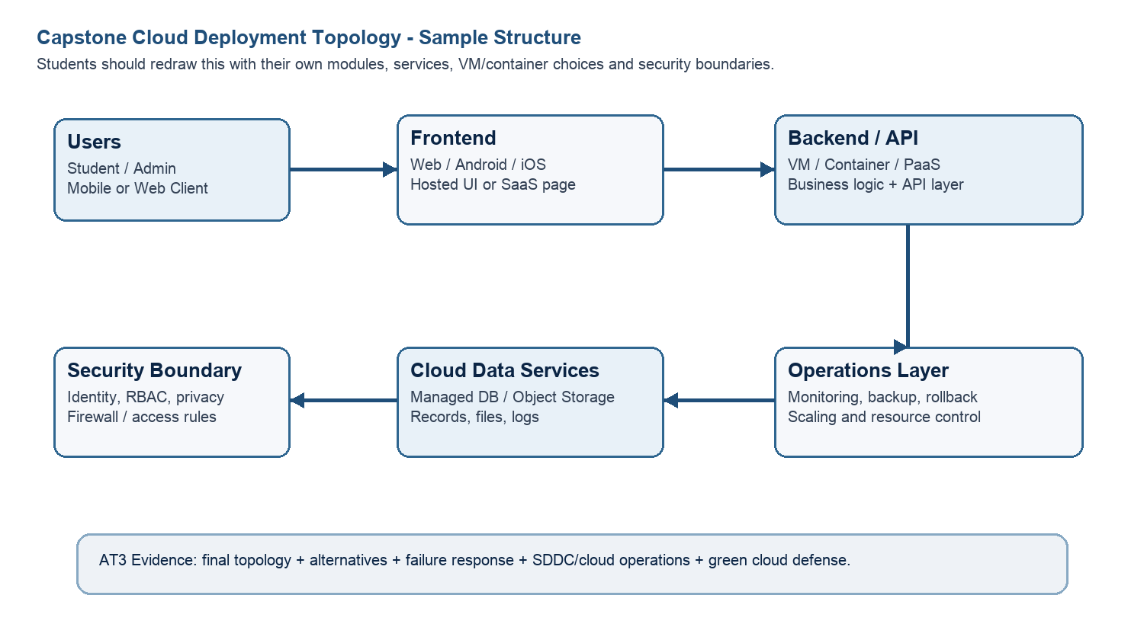
Architecture Component | Technology / Service | VM / Container / Managed Service / SaaS | Integration Method
Frontend | HTML, CSS, JavaScript, Bootstrap | VM | Accesses backend through REST APIs over HTTPS.
Backend/API | Python Flask REST API | VM | Processes client requests and communicates with the database and AI module using REST APIs.
Database | MySQL | VM/Managed Database | Stores user, sensor, irrigation, and weather data. Connected through SQL queries.
Storage | Cloud Storage / AWS S3 | Managed service | Stores reports, sensor logs, and backup files. Accessed using secure APIs.
Authentication | JWT Authentication / Firebase Authentication | Managed service | Verifies users before allowing access to application resources
Notification | Email API (SMTP) / Twilio SMS | SaaS | Sends irrigation alerts, weather warnings, and system notifications.
Analytics / AI module | Python, TensorFlow, Scikit-learn | VM | Predicts crop water requirements and communicates with the backend through REST APIs.
Paste or draw the final capstone deployment topology diagram here.
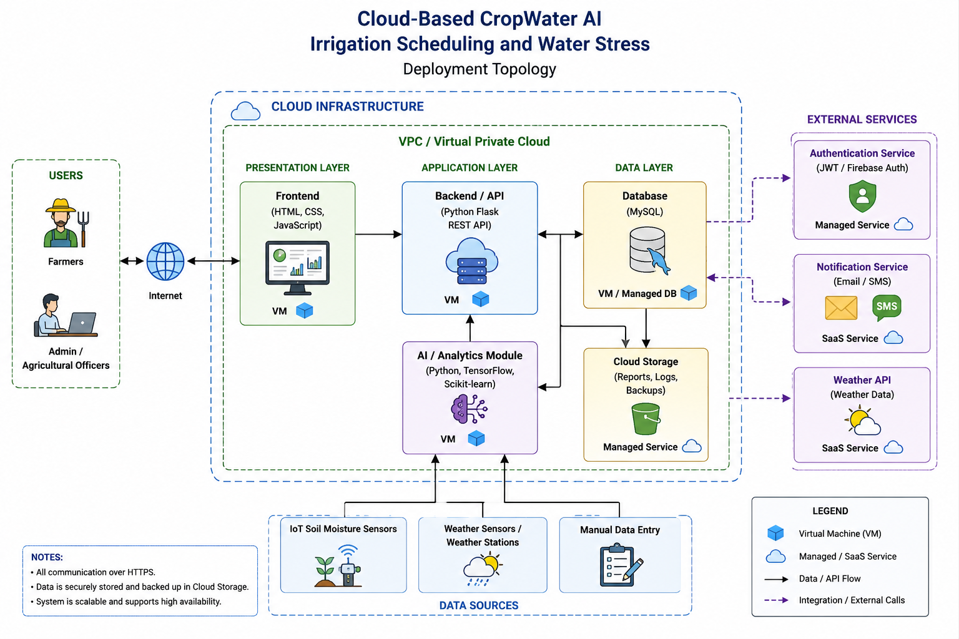

SOA/API Integration Explanation: Explain how services communicate and why modular service design is useful.
The Cloud-Based CropWater AI application follows a Service-Oriented Architecture (SOA) where each component performs a specific function. The frontend communicates with the backend using secure REST APIs. The backend processes user requests and exchanges data with the MySQL database. The AI module analyzes sensor and weather information to predict irrigation schedules and water stress. Cloud storage stores reports, backups, and historical data securely. Authentication services verify users before granting access to the application. Notification services send alerts through email or SMS. Because each service is independent, updates or maintenance can be performed without affecting the entire system. This modular architecture improves scalability, reliability, security, and ease of future expansion.

Q4: Design Alternatives, Identity, Access and Federated Cloud Privacy Case
Compare at least two deployment alternatives for your capstone product, such as single VM, multi-tier VM, containerized deployment, managed backend, federated cloud or hybrid cloud model. Justify the selected design by analyzing identity management, role-based access control, federated access, data sharing, privacy protection and security risks.
Deployment Alternative | Advantages | Limitations / Risks | Identity and Privacy Impact
Alternative 1 | Simple to deploy, low cost, easy to manage for small projects. | Limited scalability, single point of failure, reduced availability. | Basic user authentication only; if the VM fails, all services become unavailable.
Alternative 2 | Better scalability, high availability, improved security, separate application and database layers. | Higher deployment complexity and cloud management cost. | Supports secure authentication, role-based access control (RBAC), encrypted communication, and better privacy protection.
Selected design | Provides scalability, reliability, secure data storage, easy maintenance, and future expansion. | Requires cloud monitoring and proper security configuration. | Protects user information using authentication, authorization, encrypted APIs, and secure cloud storage.
Security Area |  | Student Decision
User roles |  | Two user roles are defined: Administrator and Farmer. Administrators manage users, AI models, and system settings, while farmers can monitor crops and irrigation schedules.
Authentication method |  | JWT (JSON Web Token) or Firebase Authentication is used to verify users before granting access to the application.
Role-based access control |  | RBAC restricts users to authorized features. Farmers can only access their own farm data, while administrators have full system privileges.
Federated access / partner access |  | Agricultural officers and partner organizations can securely access shared reports through authenticated APIs with limited permissions.
Sensitive data handled |  | User accounts, farm information, soil moisture data, irrigation schedules, weather information, and AI prediction results are securely stored and protected.
Privacy protection decision |  | All communication uses HTTPS, passwords are encrypted, cloud storage is protected, regular backups are maintained, and access is restricted using RBAC to ensure data privacy.
Case Analysis Response: Defend why the selected design is better for identity, access and privacy.
The multi-tier cloud architecture is selected because it provides better scalability, reliability, and security than a single virtual machine deployment. Separating the frontend, backend, and database improves performance and simplifies maintenance. User authentication is implemented using JWT or Firebase Authentication to verify user identity. Role-Based Access Control (RBAC) ensures that users can only access authorized resources. Sensitive agricultural and user information is protected using encrypted communication through HTTPS and secure cloud storage. Regular backups and monitoring improve system availability and disaster recovery. Federated access enables authorized agricultural officers to securely share information when required. Overall, the selected architecture provides a secure, scalable, and privacy-aware cloud solution for the Cloud-Based CropWater AI application.

Q5: Software-Defined Datacenter and Cloud Operations Defense Case
Analyze how your infrastructure will respond to operational and failure scenarios such as VM failure, database growth, traffic spike, credential leakage, service outage, resource contention or cost increase. Explain how SDDC concepts and cloud operations practices such as automated provisioning, software-defined networking, software-defined storage, monitoring, logging, backup, rollback, scaling, resource control and maintenance improve the final infrastructure design. Include Green Computing decisions such as resource right-sizing, storage lifecycle control, log retention, API-call reduction, scheduled shutdown, VM/container/serverless comparison and carbon/energy proxy indicators where relevant.
Operational / Failure Scenario | Expected Impact | SDDC / Cloud Operations Response | Evidence or Control
VM failure | Application becomes unavailable. | Restart VM automatically and restore from backup VM. | VM monitoring and automatic recovery
Database growth | Reduced performance and storage shortage. | Increase storage and optimize database indexing. | Cloud auto-scaling storage and regular maintenance.
Traffic spike | Slow response time. | Auto-scale virtual machines and use load balancing. | Cloud monitoring and auto-scaling
Credential leakage | Unauthorized access to the system. | Reset passwords, revoke tokens, enable MFA, and monitor logs. | JWT/Firebase Authentication and audit logs.
Service outage | Temporary service interruption. | Failover to backup server and restore services. | High Availability (HA) and cloud backup.
Resource contention | CPU and memory performance degradation. | Allocate additional VM resources dynamically. | Resource monitoring dashboard.
Cost increase | Higher cloud operational expenses. | Right-size VMs and monitor resource usage regularly. | Cloud billing dashboard and cost reports
Operational Readiness Area |  | Student Plan
Automated provisioning |  | Deploy virtual machines using reusable VM templates and automation scripts.
Software-defined networking |  | Configure virtual networks, firewall rules, and secure communication between services.
Software-defined storage |  | Store application data in scalable cloud storage with automated backups.
Monitoring and logging |  | Monitor CPU, memory, storage, API performance, and maintain centralized logs.
Backup and rollback |  | Perform scheduled backups and create VM snapshots before major updates.
Scaling and elasticity |  | Increase or decrease cloud resources automatically based on workload.
Resource control and maintenance |  | Monitor resource utilization and apply regular software updates and patches.
Green Computing and sustainability control |  | Use right-sized VMs, scheduled shutdowns, and efficient cloud resource utilization to reduce energy consumption
Green Cloud Decision |  | Student Justification
VM right-sizing from CO2 AT1 |  | Allocate only the required CPU, RAM, and storage to minimize energy consumption.
VM vs container vs serverless choice |  | Virtual Machines are selected because they provide better isolation and compatibility for the AI application.
Scheduled shutdown / idle-resource control |  | Shut down idle virtual machines during non-working hours to reduce operational cost.
Log and file retention policy |  | Retain logs only for the required period and remove unnecessary files regularly.
Storage lifecycle and backup cleanup |  | Archive old data and automatically delete expired backups.
API-call or polling reduction |  | Minimize unnecessary API requests by using efficient scheduling and caching mechanisms.
Carbon/energy proxy indicator to track |  | Monitor VM utilization, CPU usage, storage efficiency, and estimated cloud energy consumption.
Final Infrastructure Defense Statement: State whether the design is ready for prototype, pilot or production. Defend reliability, security, SDDC/cloud operations and Green Computing improvements required next.

The proposed Cloud-Based CropWater AI: Irrigation Scheduling and Water Stress system is ready for prototype deployment. The solution uses a scalable multi-tier cloud architecture with virtual machines, REST APIs, cloud storage, AI analytics, and secure authentication. High availability is achieved through VM snapshots, automated backups, monitoring, and disaster recovery mechanisms. Security is ensured using HTTPS, JWT/Firebase Authentication, Role-Based Access Control (RBAC), and encrypted data storage. Software-Defined Cloud Computing (SDDC) enables automated provisioning, software-defined networking, storage management, monitoring, and dynamic resource allocation. Green computing practices such as VM right-sizing, scheduled shutdowns, storage lifecycle management, and optimized resource utilization reduce operational cost and energy consumption. Future improvements include load balancing, container orchestration, multi-region deployment, and advanced AI model optimization for production-scale deployment.
CO2 Reflection and Individual Defense
This section must be individually written. It should show what the student understands from the complete CO2 chain: infrastructure sizing, practical configuration evidence and final operations defense.
Reflection Prompt | Student Response
What is the strongest infrastructure decision in your capstone design? | Selecting a scalable multi-tier cloud architecture with virtual machines and REST APIs because it provides better performance, security, scalability, and reliability.
Which CO2 concept became clearer after AT1, AT2 and AT3? | Virtualization, VM lifecycle management, cloud deployment, scalability, SOA integration, and Software-Defined Cloud Computing became much clearer.
Which risk is most serious for your capstone: failure, cost, privacy, scaling or sustainability? | Data privacy and system availability are the most critical risks because the application stores agricultural and user information that must remain secure and continuously available.
What evidence would you show during viva to defend your infrastructure design? | VM sizing workbook, deployment topology diagram, VM lifecycle documentation, architecture design, cloud deployment screenshots, monitoring reports, and project implementation evidence.
What will you improve before final capstone deployment? | Implement load balancing, enable automatic scaling, strengthen security, optimize AI model performance, improve monitoring, and enhance disaster recovery for production deployment.

Student-Facing Assessment Criteria
Criteria | Descriptor
Capstone continuity | The answer uses the same capstone title and connects CO1, CO2 AT1 and CO2 AT2 evidence.
Virtualization and lifecycle reasoning | VM, image, snapshot, clone, container or managed-service decisions are technically justified.
Topology and integration clarity | Architecture diagram and SOA/API explanation show clear module interaction.
Identity, access and privacy | Roles, authentication, RBAC, federated access, sensitive data and privacy decisions are defended.
SDDC/cloud operations | Failure response, monitoring, logging, scaling, backup, rollback and resource control are addressed.
Green Computing defense | Right-sizing, retention, API efficiency, idle-resource control and sustainable cloud choices are explained.
Submission quality | GitHub, template completion, evidence references and individual reflection are complete.
GitHub and Google Classroom Submission
Repository Item | Expected Content
README.md | Capstone title, student details, final VM recommendation, deployment topology summary and AT3 evidence index.
Completed AT3 document | This completed editable DOCX or exported PDF if instructed.
Diagram image | Final topology diagram if created separately.
Evidence references | Links or screenshots from CO1, CO2 AT1 and CO2 AT2 as needed.
Green Computing note | Short README section explaining sustainable cloud choices and resource-control decisions.
Google Classroom | Submit the GitHub repository link through GCR.
Student Assurance
I confirm that this case analysis, design reasoning, topology diagram and final defense statement were prepared individually by me for the stated capstone title. I have not uploaded passwords, tokens, private keys or sensitive account information.
Student Name | G.Lakshmi Mounika
Register Number | 192372110
Signature | Mounika
Date | 31-07-26

Faculty Verification
Faculty Name | Dr C. Rajesh Babu
Employee ID | SSETSCS415
Constructive Feedback / Remarks
Strength Observed
Improvement Suggested
Signature / Date

